EDUCATION WEEK
Vol. 39, Issue 13, Pages 1, 12
Published in Print: November 13, 2019, as Screen Time Up as Reading Scores Drop. Is There a Link?

Screen Time Up as Reading Scores Drop. Is There a Link?

American students have never had more access to digital devices for reading in and out of school. Now emerging research and troubling results on the test dubbed the Nation’s Report Card raise questions about what effect all this digital access could have on students’ longterm reading skills.
A little more than 1 in 3 American students read proficiently in grades 4 or 8, according to the 2019 National Assessment of Educational Progress, released at the end of last month. Reading scores in both grades declined significantly across states, races, and income levels, in public and private schools.
Students have actually lost ground since 2017 on both of the NAEP’s main reading content areas: literary experience, such as fiction analysis, and reading for information, such as finding evidence to support an argument. Both grades declined significantly in both areas from 2017 to 2019, but the drop was larger for literary skills. In fact, 8th graders perform worse now than they did in 2009 in literary experience.
The results have spurred a flurry of questions about what could drive such a broad-based drop. The 2019 administration marks the second time most students have taken a digital version of the NAEP itself, but Peggy Carr, the associate commissioner for the National Center for Education Statistics, which administers the NAEP, said the neither the testing mode nor changing demographics explain the drop in performance.
“I really think it’s important to just take a look at that and say, well, maybe it’s more something in the culture rather than specific policies,” said Nat Malkus, the deputy director of education policy studies at the American Enterprise Institute, noting that states’ demographic and policy changes in education do not explain the widescale declines.
“My suspicion rides on the ubiquity of screens and our attempts to make those useful in educating kids, and the concomitant increase in their use outside of school,” Malkus said. “It could just be that actually technology is not the answer for education, but that it’s sort of the enemy ... wearing down the attention span that it takes to develop a sense of reading for pleasure.”
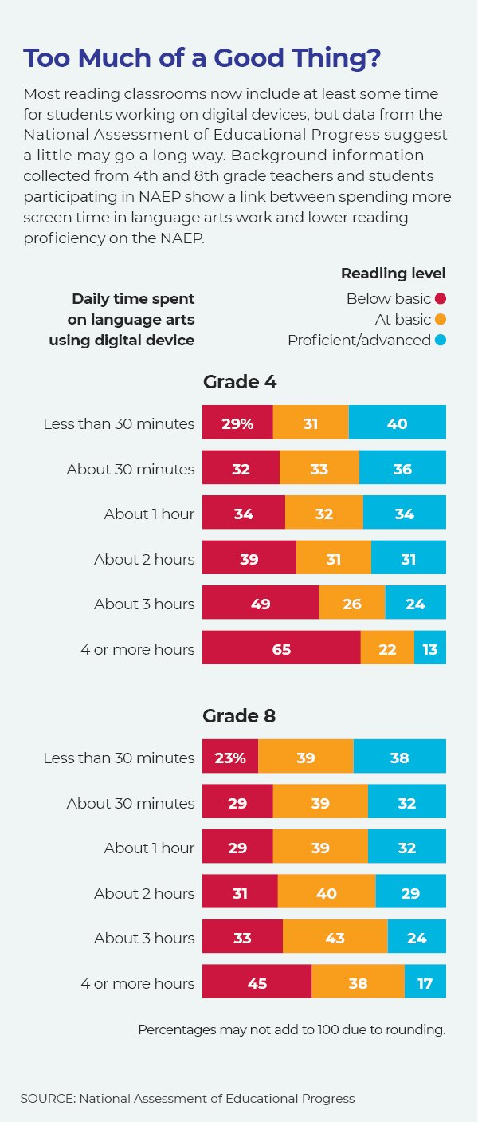

Getting Into the Habit
The nonprofit Common Sense Media’s annual census of children’s media use, released the same week as the NAEP, found that 94 percent of English/language arts teachers surveyed said they used digital programs for core curriculum activities several times a month. And 8- to 12-year-olds—the age group that includes grade 4—spend on average five hours a day outside of schoolwork on screens. The report also found that fewer children were developing a habit of reading, with only 38 percent of students reporting they enjoyed reading “a lot”—down from 41 percent in 2015.
The concerns come amid a broader debate over children’s increasing screen time, from television and video games to online and mobile devices. In the journal JAMA Pediatrics, a new analysis of 58 studies covering more than 480,000 children and teenagers found more television, video game, and leisure internet time were linked to lower performance in reading and math, though screen time across the board did not hurt students’ academics.
In a 2018 Education Week survey, a wide majority of American principals reported students spending too much time on screens, though they were more likely to report a good balance for using digital platforms in their own schools.
“Children have become much more immersed in their technologies than we ever thought they would be,” said Patricia Alexander, an education professor at the University of Maryland, College Park, who studies print and digital reading development, “And yet essentially what we’re doing ... is to put tablets in the hands of kindergartners and assume they will know how to regulate their use of them. And none of that sits well with the data.”

Heavy Digital Users
According to background information collected with the NAEP, more than 9 in 10 U.S. students in grades 4 and 8 have access to a computer, tablet, or smartphone for reading at home. The vast majority have more than one.
An Education Week analysis of NAEP background data found that in both grades 4 and 8, spending more time using a computer or digital device for English and language arts work was associated with lower reading proficiency on the test. For example, students who used digital devices for reading work less than 30 minutes a day scored on average 8 scale points higher than those who used computers in language arts for longer periods of time. These light digital users scored 26 scale points higher than the students who spent the longest reading periods on digital devices, four hours or more a day. To put that into context, one year of school equals roughly 12 points on the NAEP’s 500-point scale.
That translates into twice as many heavy digital users as light users scoring below basic on the NAEP, and nearly twice as many light digital users scoring at NAEP’s advanced proficiency level. It’s not clear whether using more digital reading platforms lowers students’ reading skills, or poor readers are receiving more hours of remedial work via computers, or both.
And the link between more digital time and lower scores in language arts was even stronger, based on a separate study of 2017 NAEP data from high-poverty schools.
“Schools have spent millions and millions of dollars installing and updating and maintaining technologies because they believe they are critical for students to do well and learn,” Alexander said. “The problem is that what we’re finding now is all of this digital is actually changing the minds of students, the habits of students in a very broad way that is not necessarily facilitative of deep learning.”
Studies have found higher screen time linked to worse sleep habits and eyesight, poorer attention, and lower academic progress—but in general, these studies have looked at screen exposure more broadly, rather than reading habits in particular.
However, three research analyses in the past two years have coalesced concerns around differences in how students read in print versus online.
For example, students at all ages tend to favor reading in print more than online, and report growing tired more quickly when reading digitally, which some studies have credited to increased eyestrain from reading smaller or backlit text. But the biggest difference between digital and print reading seems to come from digital interactivity. Including hyperlinks, videos, and other interactive elements encourages students to jump around on the story and among texts on different pages, rather than reading linearly.
One meta-analysis comparing digital and traditional storybooks found some attention-getting elements, like sound effects, improved comprehension for young children, but that interactive features like pop-up dictionaries or sidebars distracted students and hurt comprehension. Both the potential good and bad effects were stronger for disadvantaged students.

Differences Across Platforms
A study of reading behavior changes found that as students move to reading online, they tend to read faster, browsing and skimming more and looking for key words. They read less of a longer text and tend to reread less, and as students spend more time reading digitally, they become more likely to read print text in the same way. By contrast, the habits associated with print reading, such as deeper and more concentrated periods of reading, with students annotating and highlighting as they read, did not transfer to reading digital text as easily.
In three separate meta-analyses in the last two years, researchers have found the habits associated with reading digitally can decrease students’ skills in following a narrative, and comprehending text deeply—exactly the skills measured under NAEP’s literary experience content.
But that electronic libraries have given low-income students vastly more access to reading materials than most poorly resourced families and schools have without them. And Alexander noted, while computers have been used in schools for decades, widescale, extensive use of computers and tablets in reading classrooms has boomed only in the last decade, meaning that it’s still too early to tell how learning to read on digital devices may change children’s reading skills and habits in the long term.
“Here’s what we do know about reading: You read better when you read in print, meaning you remember more of what you read, you understand it deeper. ... We keep trying to understand why, because in study after study, this is happening,” Alexander said.
Related Stories
- "'No Progress' Seen in Reading or Math on Nation's Report Card," (Inside School Research) October 30, 2019.
- "Teens' Online Video Viewing Soared Over the Past Four Years, Report Finds," (Digital Education) October 29, 2019.
- “'Nation's Report Card' to Get Trimmed, Four Subjects Dropped,” July 24, 2019.
- “Low Scorers Losing Ground on NAEP,” April 25, 2018.

